MANAGED IDENTITES

SYSTEM-ASSIGNED MANAGED IDENTITY

NOTE: YOUR ACCOUNT HAS TO HAVE THE VIRTUAL MACHINE CONTRIBUTOR ROLE.

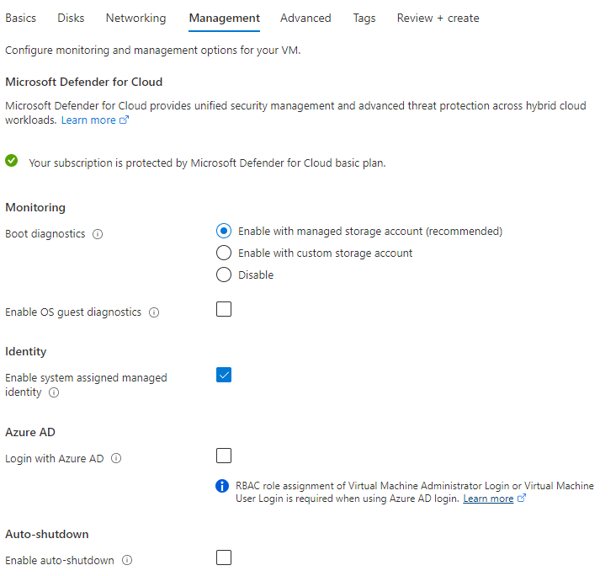

TO GET TO THE ABOVE, GO TO VIRTUAL MACHINES, CREATE A NEW ONE AND FILL OUT YOUR INFORMATION TILL YOU GET TO THE MANAGEMENT TAB. ON THE MANAGEMENT TAB SCROLL DOWN TO THE IDENTITY SECTION AND CHECK “ENABLE SYSTEM ASSIGNED MANAGED IDENTITY”

USER-ASSIGNED MANAGED IDENTITY

NOTE: YOUR ACCOUNT HAS TO HAVE THE VIRTUAL MACHINE CONTRIBUTOR AND MANAGED IDENTITY OPERATOR ROLE WHICH REQURIES A P1 OR P2 LICENSES.

YOUR NOT ALLOWED TO ASSIGN A USER-ASSIGNED IDENTITY DURING A CREATION OF A VM. THEREFORE, YOU HAVE TO FOLLOW THE FOLLOWING STEPS:

1. SEARCH VIRTUAL MACHINES IN THE SEARCH BAR AND NAVIGATE TO THE DESTINED VM, SELECT IDENTITY AND GO TO THE USER ASSIGNED TAB SO YOU CAN ADD THE USER TO THE VM.
2. SELECT THE USER OR RESOURCE GROUP AND COMPLETE THE PROCESS

FOR MORE INFORMATION CHECK OUT : [Configure managed identities using the Azure portal - Azure AD - Microsoft Entra | Microsoft Docs](https://docs.microsoft.com/en-us/azure/active-directory/managed-identities-azure-resources/qs-configure-portal-windows-vm)